Programming in Chemistry: Solving Simple and Complex Equations on TI-83/84

Faculty Mentor: Dr. Sivanadane Mandjiny
Authors: Lindsay Branch and Dina Abumoshen
Acknowledgements
We would like to thank our faculty mentor, Dr. Sivanadane Mandjiny, for his guidance not only on this project but in our academic and personal lives as well. He is a phenomenal professor and mentor, and we would not be where we are without him. We would also like to thank Mrs. Felicia Scott for allowing us to teach her students the things we have discovered. We are very grateful to the Esther G. Maynor Honors College for giving us the opportunity to research and present on topics that we love.
Introduction
Through this project, we were interested in determining different algorithms that will help current students do lab calculations, help tutors to tutor other students, and better their understanding of chemistry. One of the larger goals of this project was to make lab work easier for current college students as this is a much more efficient way to do lab calculations. These programs have helped students determine the efficiency of different reactions and determine the right concentrations to get a desired rate. These programs will also be used as a tool for tutors to check their students' work. The balancing and redox reaction procedures is a much more efficient way to do lab work and check tutee’s work. The limiting reaction, vapor pressure, and phase change TI-84 programs are an efficient way to work through different labs involving these types of problems. Through this project, we hoped to help students understand how important chemistry is in everyday life by giving applicable examples for different reactions. Surveys were conducted for the classes that were taught how to use the algorithms and have been included in this study to validate our work. Throughout this project we became proficient in calculating different kinds of reactions, learned how to make calculator algorithms, discovered the best way to transfer information from one calculator to another, and hope to publish some of our algorithms for future students to use.
Table of Contents

Balancing Simple and Complex Reactions Theory……………………. 5
Procedure …………………………………………………………………6
Finding the Limiting and Excess Reactants of a Reaction Theory …..12
Calculator Procedure …………………………………………………...13
Finding the Limiting and Excess Reactants of a Reaction Program ...16
Balancing Redox Reactions Theory ……………………………………17
Balancing Acidic Redox Reactions on a TI-84 Calculator Procedure .18
Balancing Basic Redox Reactions on a TI-84 Calculator Procedure.. 23
Vapor Pressure Theory………………………………………………… 28
Vapor Pressure Procedure on TI-84 Calculator ………………………29
Vapor Pressure Program for TI-84 Calculator………………………. 32
Phase Change Theory………………………………………………….. 33
Phase Change Program for TI-84 Calculator………………………… 34
Phase Change Procedure on TI-84 Calculator ………………………..35
Survey…………………………………………………………………….36
References ……………………………………………………………….37

Balancing Simple and Complex Reactions

The law of conservation of mass states that in a chemical reaction, mass is neither made nor destroyed. Therefore the mass of one element on the reactant side should in theory be alike to the mass on the product side. In other words, in order to satisfy the law of conservation of mass a chemical reaction must be balanced. When calculating the amount of moles, total mass, or even the amount of electrons transferred between compounds a balanced equation must be used.

Balancing Simple and Complex Reactions Calculator Procedure
Example problem
Cu + HNO₃ → Cu(NO₂)₂ +NO+H₂O
Balance the chemical reaction
Step One: Find the Matrix by Separating Each Element as Columns and Each Compound as Rows
*Matrix will be (4x5)*
Elements ↓ | Compounds separate → | Cu | HNO₃ | Cu(NO₂)₂ | NO | H₂O
Cu
H
N
O

Step Two: Select Matrix on the Calculator

Step Three: Select Edit

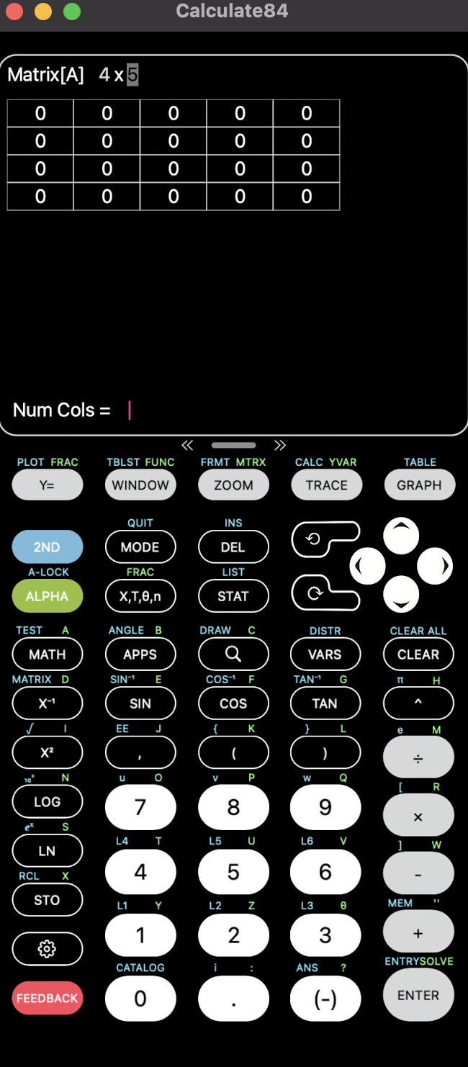
Step Four: After Identifying these Elements, Find the Number of Particles of Each Element that are Available to the Compound
(Ask yourself, how many hydrogen particles are in H₂O)
Elements ↓ |  | Number of particles of each element in each compound→ | Cu | HNO₃ | Cu(NO₂)₂ | NO | H₂O
Cu |  |  | 1 | 0 | 1 | 0 | 0
H |  |  | 0 | 1 | 0 | 0 | 2
N |  |  | 0 | 1 | 2 | 1 | 0
O |  |  | 0 | 3 | 4 | 1 | 1

Step Five: Enter the Values into the Matrix on the Calculator
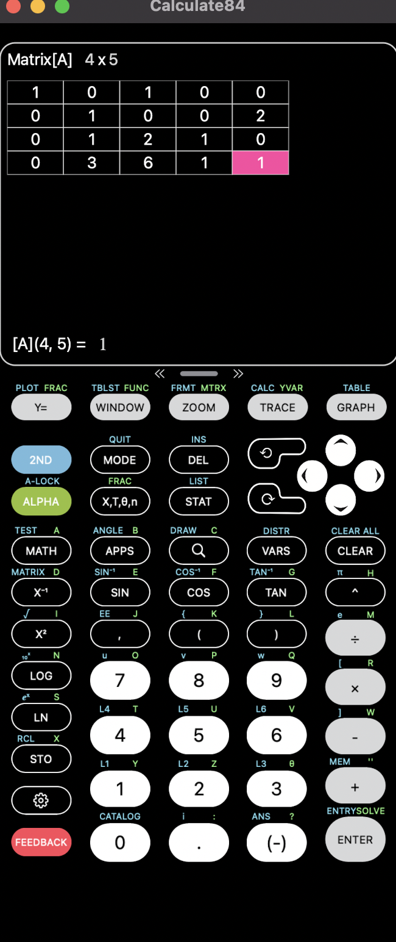
Step Six: Quit Matrix

Step Seven: Select Matrix

Step Eight: Select Math Option in Matrix

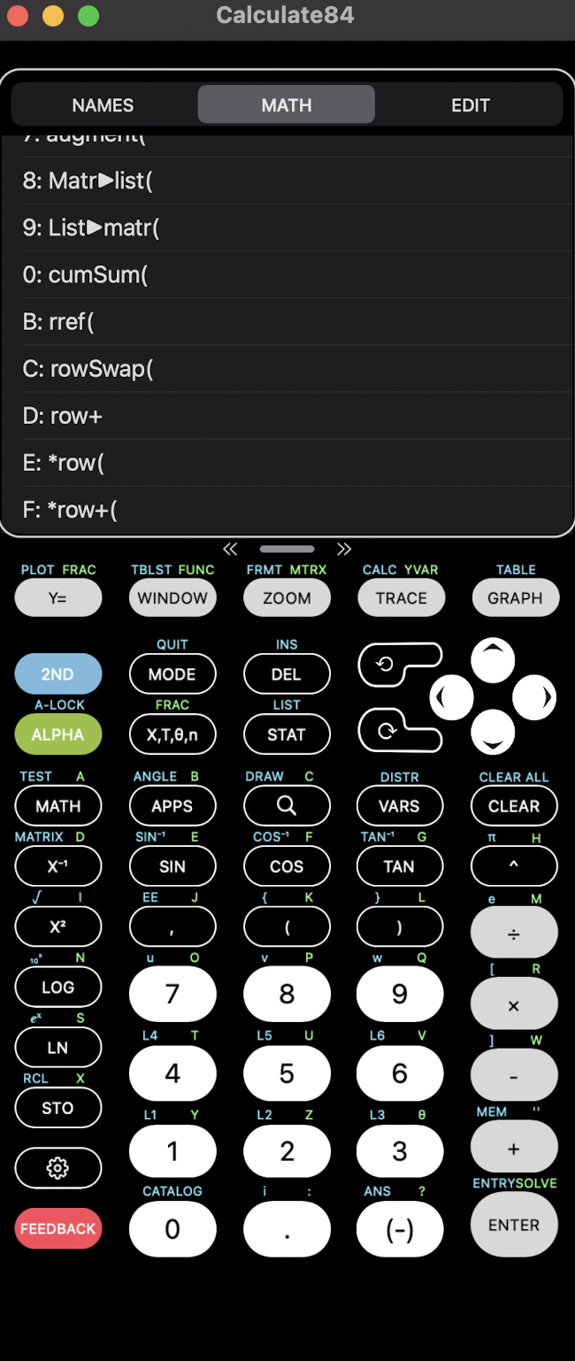

Step Nine: Select rref ( )

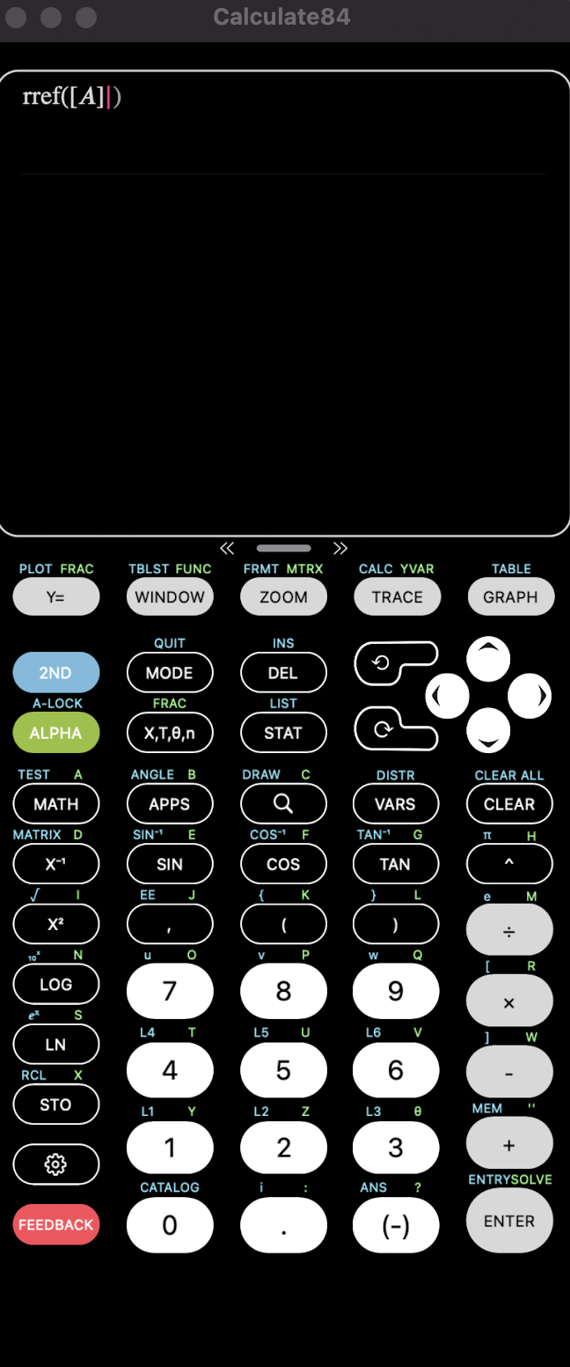

Step Ten: Select Matrix

Step Eleven: Enter Matrix into rref ( )

Step Twelve: Select Math

Step Thirteen: Select Fraction

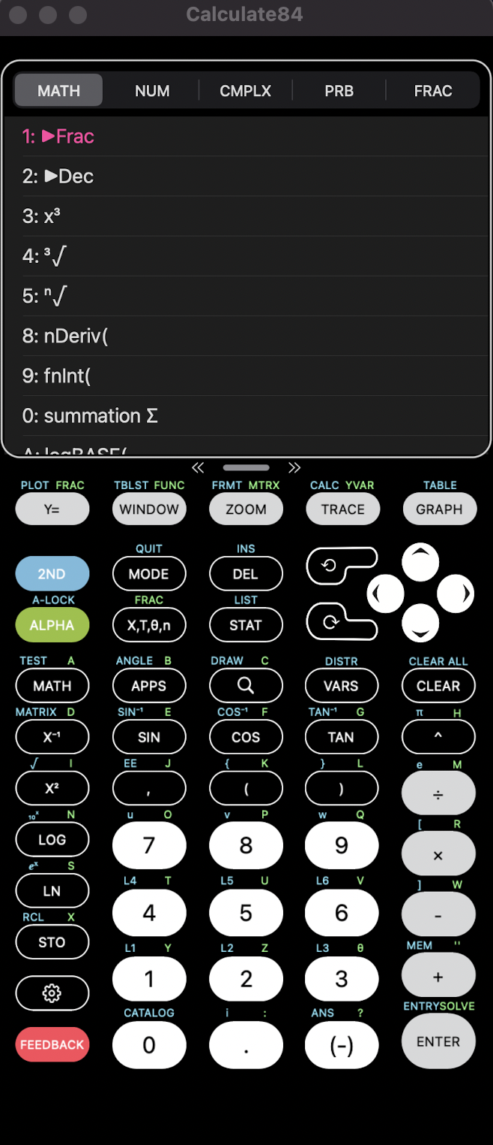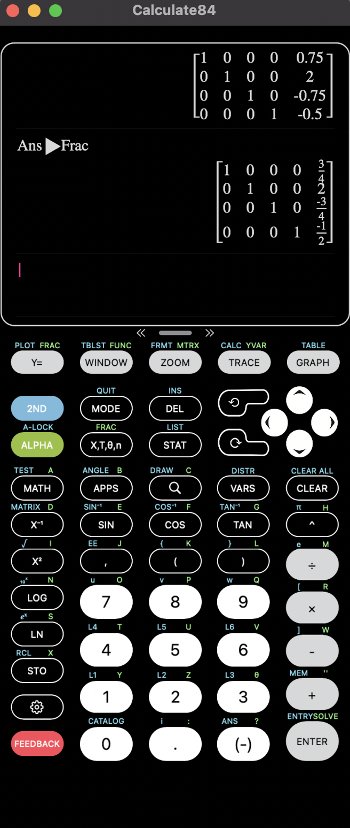

* This table should be shown*
1 | 0 | 0 | 0 | 3/4
0 | 1 | 0 | 0 | 2
0 | 0 | 1 | 0 | -3/4
0 | 0 | 0 | 1 | -1/2

Step Fourteen: Work from Right to Left and Add Numbers in the Final Column Back into the Chemical Equation
*(ignore negatives, and add 1 as a coefficient to compounds at the end that does not have coefficient in the graph (in this case H₂O))*

¾ Cu+ 2HNO₃ → ¾ Cu(NO₂)₂ +½ NO+ 1 H₂O
Step Fifteen: Get Rid of the Fractions by Multiplying like Denominators (highest common factor in the denominator) (in this case 4)

3Cu+8HNO₃ → 3Cu(NO₂)₂+2NO+4H₂O (final Balanced answer)

Finding the Limiting and Excess Components of a Reaction
The limiting reactant in a chemical reaction is the reactant that will be consumed completely. When there is no more of that reactant, the reaction cannot proceed and keeps the reaction from continuing. The excess reactant is the reactant that will be left over and could keep reacting if the other had not been consumed.
Finding the Limiting and Excess Components of a Reaction on a TI-84 Calculator Procedure
CO+H₂O → CO₂ + H₂
A + B → C + D
Step One: Select Stat Option of the Calculator
Step Two: Select Edit Option
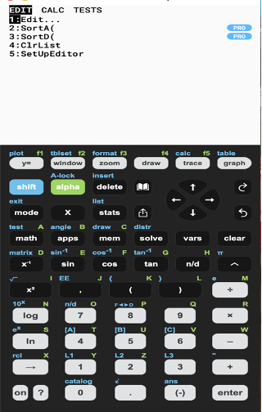

Step Three: Input Data as Listed Below:
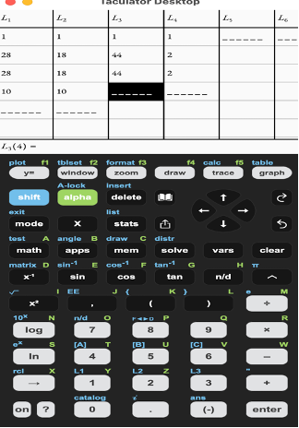
 | CO | H₂O | CO₂ | H₂
Moles of Each | 1 | 1 | 1 | 1
Formula Weight of Each | 28 g/mol | 18 g/mol | 44 g/mol | 2 g/mol
Mass of each Compound present | 28 g | 18 g | 44 g | 2 g
Limiting/Excess Amounts? | 10 g | 10 g | ? | ?
*Note: always put something in the fourth column (just zero if you do not have a second product)

Step Four: Quit Stat Option

Step Five: Select Program Option of Calculator

Step Six: Select Limiting Program

Step Seven: Select Enter to Run Program

Answer:
B is Limiting 15.71 g
A is Excess 3.57 g

Finding the Limiting and Excess Components of a Reaction on a TI-84 Calculator Program

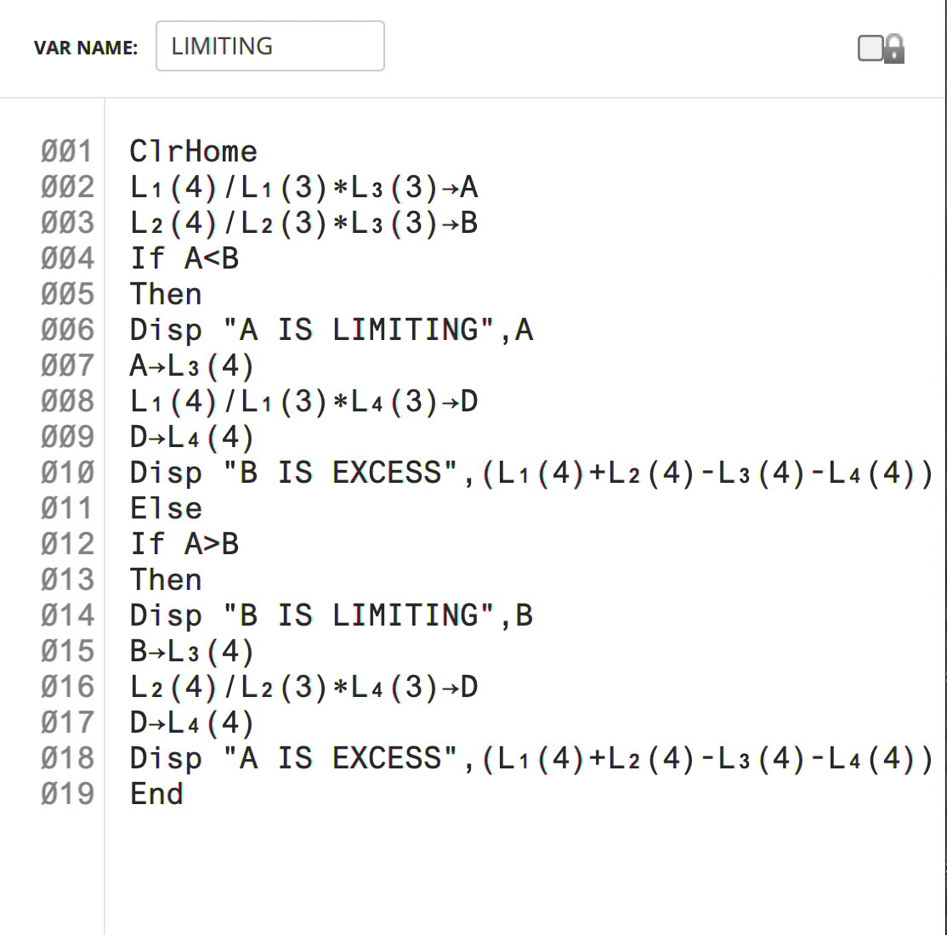

Balancing Redox Reactions
Oxidation–reduction reactions, also known as redox reactions, involve transferring electrons from one species to another. The species that loses electrons is oxidized, while the species that gains electrons is reduced. To balance a redox equation, the reaction is separated into two half-reactions, one oxidation and one reduction reaction. Both half-reactions are balanced and then recombined with its coefficients so that the electrons cancel.
Balancing Redox Reactions on a TI-84 Calculator Procedure
Step One: Balance Acidic Red-Ox Reaction
Example Problem:
H₂O must be added on the product side and H⁺ must be added on the reactant side
Fe²⁺ + MnO₄⁻ → Fe³⁺ + Mn²⁺
Fe²⁺ → Fe³⁺ + e⁻ → Oxidation (x5)
5e⁻ + 8H⁺ + MnO₄⁻ → Mn²⁺ + 4H₂O → Reduction

5Fe²⁺ → 5Fe³⁺ + 5e⁻
5e⁻ + 8H⁺ + MnO₄⁻ → Mn²⁺ + 4H₂O
Added together will equal final balanced equation:
8H⁺ + 5Fe²⁺ + MnO₄⁻ → 5Fe³⁺ + Mn²⁺ + 4H₂O
Step Two: Find the Matrix by Separating Each Element as Columns and Each Compound as Rows
*Matrix will be (5x6)*
Step Three: After Identifying these Elements, Find the Number of Particles of Each Element that are Available to the Compound

Acidic Reaction (H⁺):
H⁺ + Fe²⁺ + MnO₄⁻ → Fe³⁺ + Mn²⁺ + H₂O

 | Number of Molecules in H⁺ | Number of Molecules in Fe²⁺ | Number of Molecules in MnO₄⁻ | Number of Molecules inFe³⁺ | Number of Molecules in Mn²⁺ | Number of Molecules in H₂O
H | 1 | 0 | 0 | 0 | 0 | 2
Fe | 0 | 1 | 0 | 1 | 0 | 0
Mn | 0 | 0 | 1 | 0 | 1 | 0
O | 0 | 0 | 4 | 0 | 0 | 1
Charge | 1 | 2 | -1 | +3 | +2 | 0

Step Four: Select Matrix on the Calculator

Step Five: Select Edit

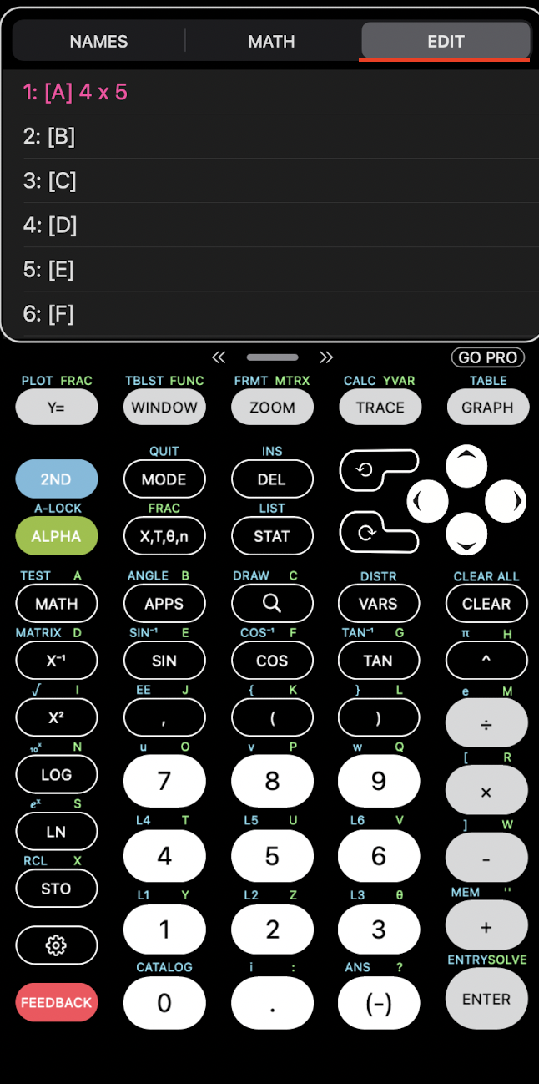

Step Six: Enter Values into the Matrix on the Calculator

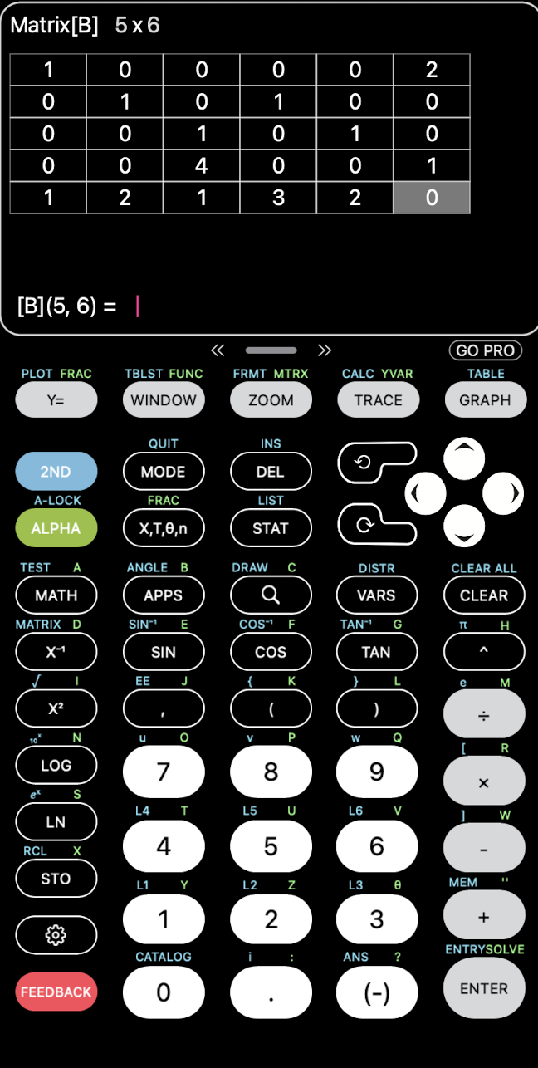

Step Seven: Quit Matrix

Step Eight: Select Matrix

Step Nine: Select Math Option in Matrix

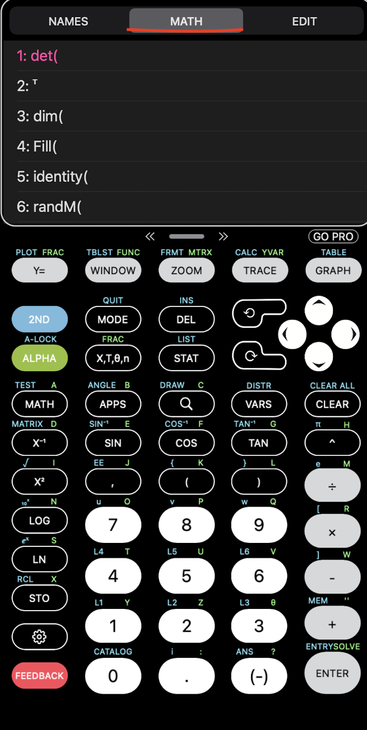

Step Ten: Select rref ( )

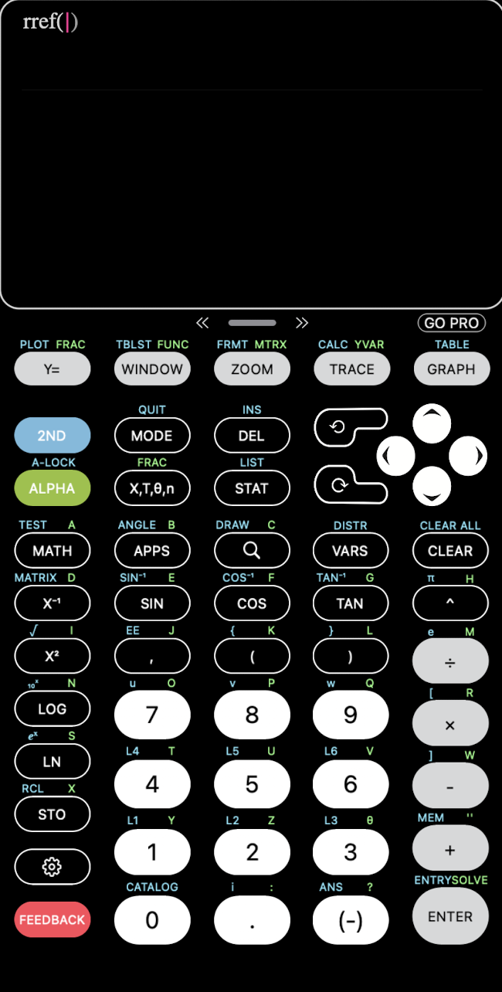

Step Eleven: Select Matrix

Step Twelve: Enter Matrix into rref ( )

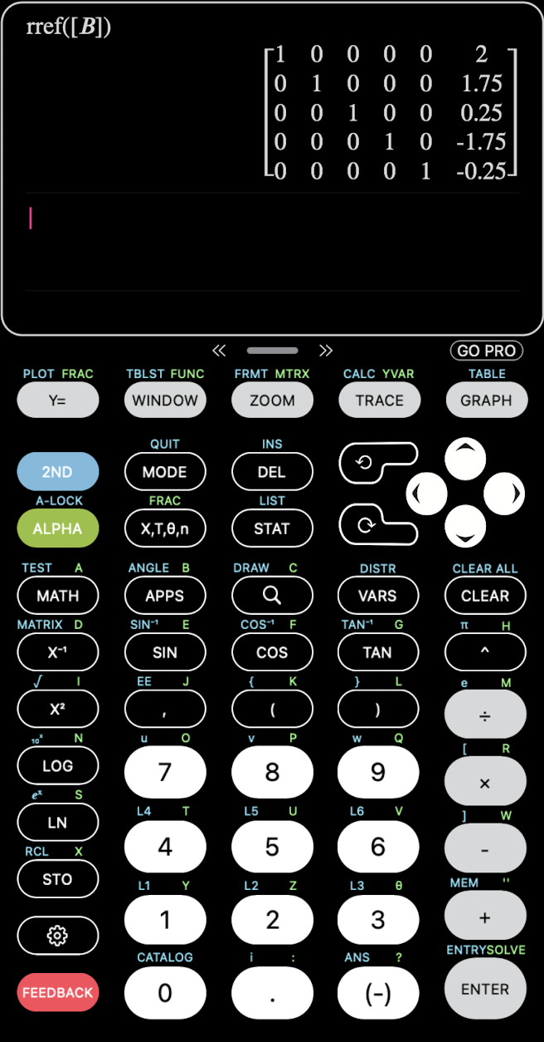

Step Thirteen: Select Math

Step Fourteen: Select Fraction

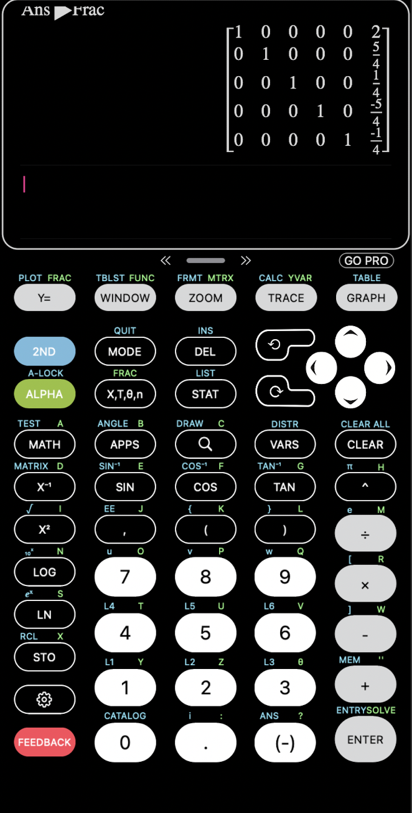

1 | 0 | 0 | 0 | 0 | 2
0 | 1 | 0 | 0 | 0 | 5/4
0 | 0 | 1 | 0 | 0 | 1/4
0 | 0 | 0 | 1 | 0 | -5/4
0 | 0 | 0 | 0 | 1 | -1/4

Step Fifteen: Work from Right to Left and Add Numbers in the Final Column Back into the Chemical Equation
*(ignore negatives, and add 1 as a coefficient to compounds at the end that does not have coefficient in the graph)*
Step Sixteen: Get Rid of Fraction by Multiplying like Denominators (highest common factor in the denominator)
8H⁺ + 5Fe²⁺ + MnO₄⁻ → 5Fe³⁺ + Mn²⁺ + 4H₂O

Step One: Balance Basic Red-Ox Reaction:
Example Problem:
H₂O must be added on the reactant side and OH⁻ must be added on the product side
I⁻ + MnO₄⁻ → I₂ + MnO₂
I⁻ + I₂ + 2e⁻ → (x3)

4OH⁻ + 4H⁺ + MnO₄⁻ → MnO₂ +2H₂O + 4OH⁻
4H₂O + MnO₄⁻ → MnO₂ +2H₂O + 4OH⁻
3e⁻ + 2H₂O + MnO₄⁻ → MnO₂ + 4OH⁻ → (x2)

6I⁻ + 3I₂ + 6e⁻
6e⁻ + 4H₂O + 2MnO₄⁻ → 2MnO₂ + 8OH⁻
Added together will equal final balanced equation:
4H₂O +6I⁻ + 2MnO₄⁻ → 3I₂ + 2MnO₂ + 8OH⁻

Step Two: Find your matrix by separating each element as your columns and each compound as your rows
*Matrix will be (5x6)*
Step Three: After identifying these elements, find the number of particles in each element that are available to the compound

Basic Reaction (OH⁻):
H₂O + I⁻ + MnO₄⁻ → I₂ + MnO₂ + OH⁻

 | Number of Molecules in H₂O | Number of Molecules in I⁻ | Number of Molecules in MnO₄⁻ | Number of Molecules in I₂ | Number of Molecules in MnO₂ | Number of Molecules in OH⁻
H | 2 | 0 | 0 | 0 | 0 | 1
O | 1 | 0 | 4 | 0 | 2 | 1
I | 0 | 1 | 0 | 2 | 0 | 0
Mn | 0 | 0 | 1 | 0 | 1 | 0
Charge | 0 | -1 | -1 | 0 | 0 | -1

Step Four: Select Matrix on the Calculator

Step Five: Select Edit

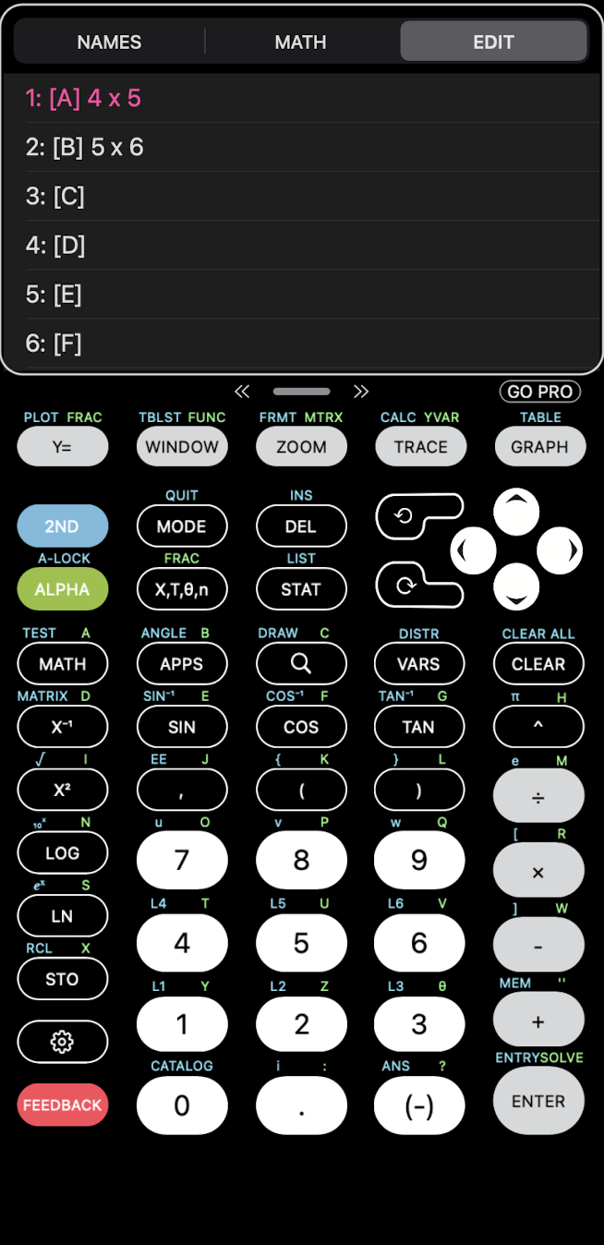

Step Six: Enter Values into the Matrix on the Calculator

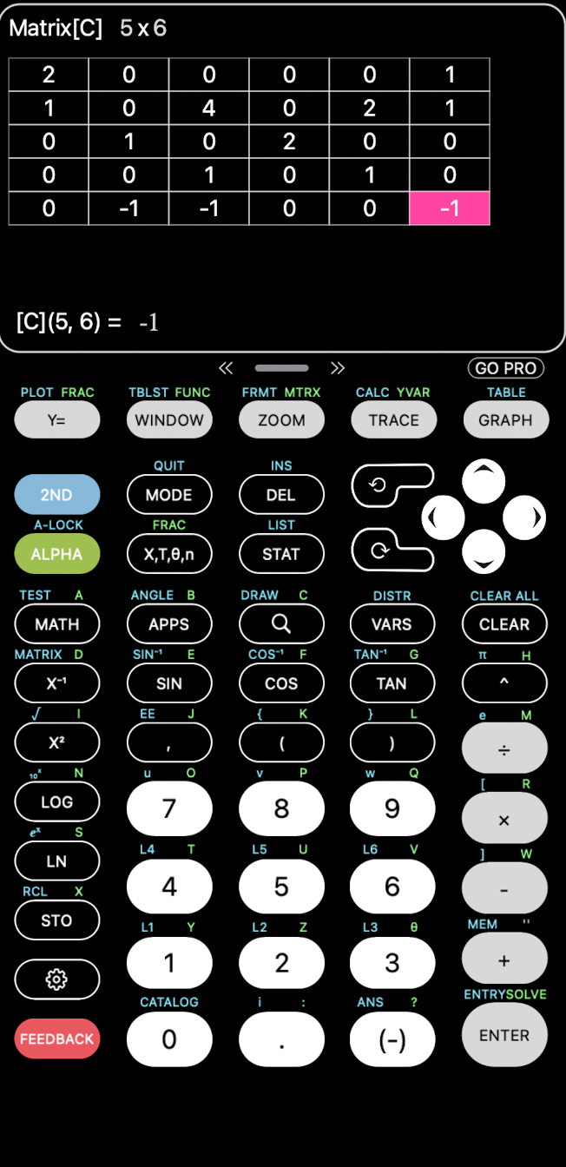

Step Seven: Quit Matrix

Step Eight: Select Matrix

Step Nine: Select Math Option in Matrix

Step Ten: Select rref ( )

Step Eleven: Select Matrix

Step Twelve: Enter Matrix into rref ( )

Step Thirteen: Select Enter

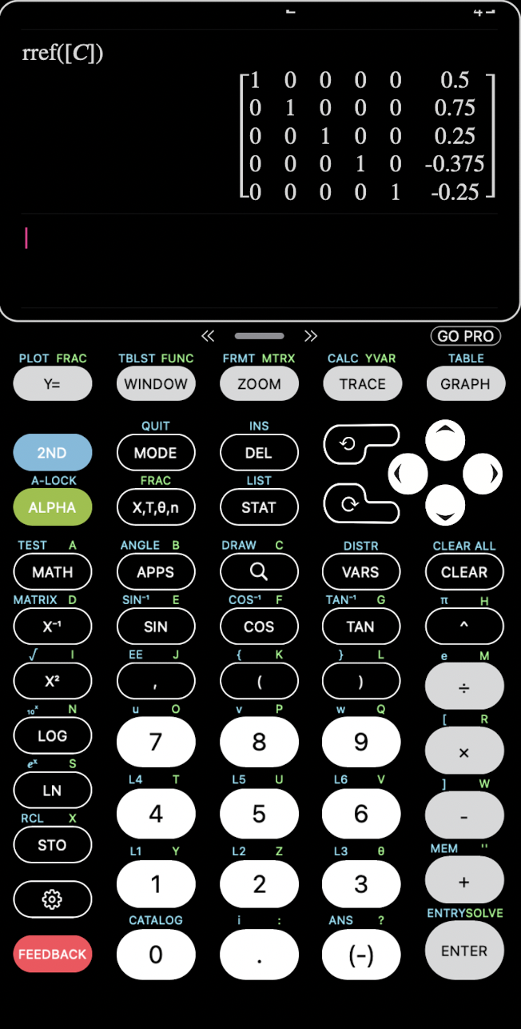

Step Fourteen: Math
Step Fifteen: Select Fraction

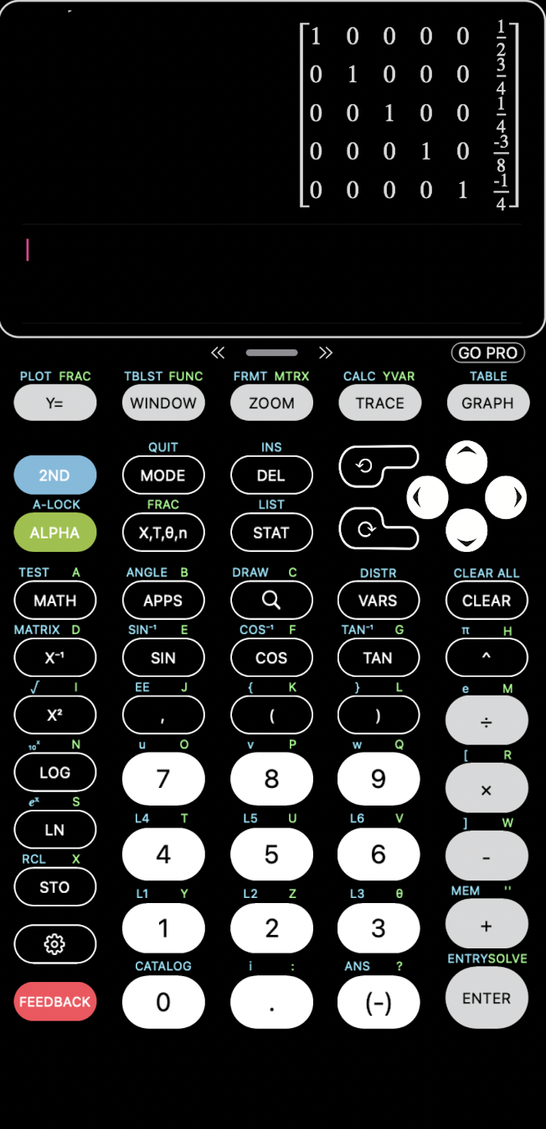

1 | 0 | 0 | 0 | 0 | 1/2
0 | 1 | 0 | 0 | 0 | 3/4
0 | 0 | 1 | 0 | 0 | 1/4
0 | 0 | 0 | 1 | 0 | -3/8
0 | 0 | 0 | 0 | 1 | -1/4

Step Sixteen: Work from Right to Left and Add Numbers in the Final Column Back into the Chemical Equation
*(ignore negatives, and add 1 as a coefficient to compounds at the end that does not have coefficient in the graph)*
Step Seventeen: Get Rid of the Fractions by Multiplying like Denominators (highest common factor in the denominator)
Final Answer:
4H₂O +6I⁻ + 2MnO₄⁻ → 3I₂ + 2MnO₂ + 8OH⁻

Vapor Pressure
Vapor pressure is the pressure that is applied on the walls of a sealed container when a substance in the container converts to a gas. A temperature increase causes an increase in vapor pressure. To find the vapor pressure at a certain temperature, the Clausius-Clapeyron equation is used.

Vapor Pressure Procedure on TI-84 Calculator
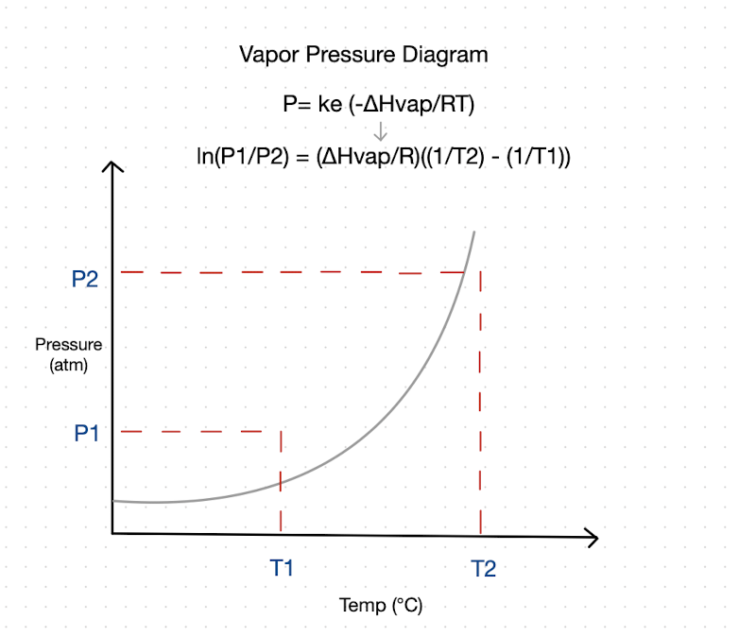
ln(P1/P2) = (ΔHvap/R)((1/T2) - (1/T1))

R= 8.314 J/mol·K
ΔHvap = 42,000 J/ mol K
P1= 22.3 mm Hg
P2= ?
T1= 298 k
T2= 310 K

Step One: Select Stats Option on the Calculator

Step Two: Select Edit Option
Step Three: Insert Data as Listed Below: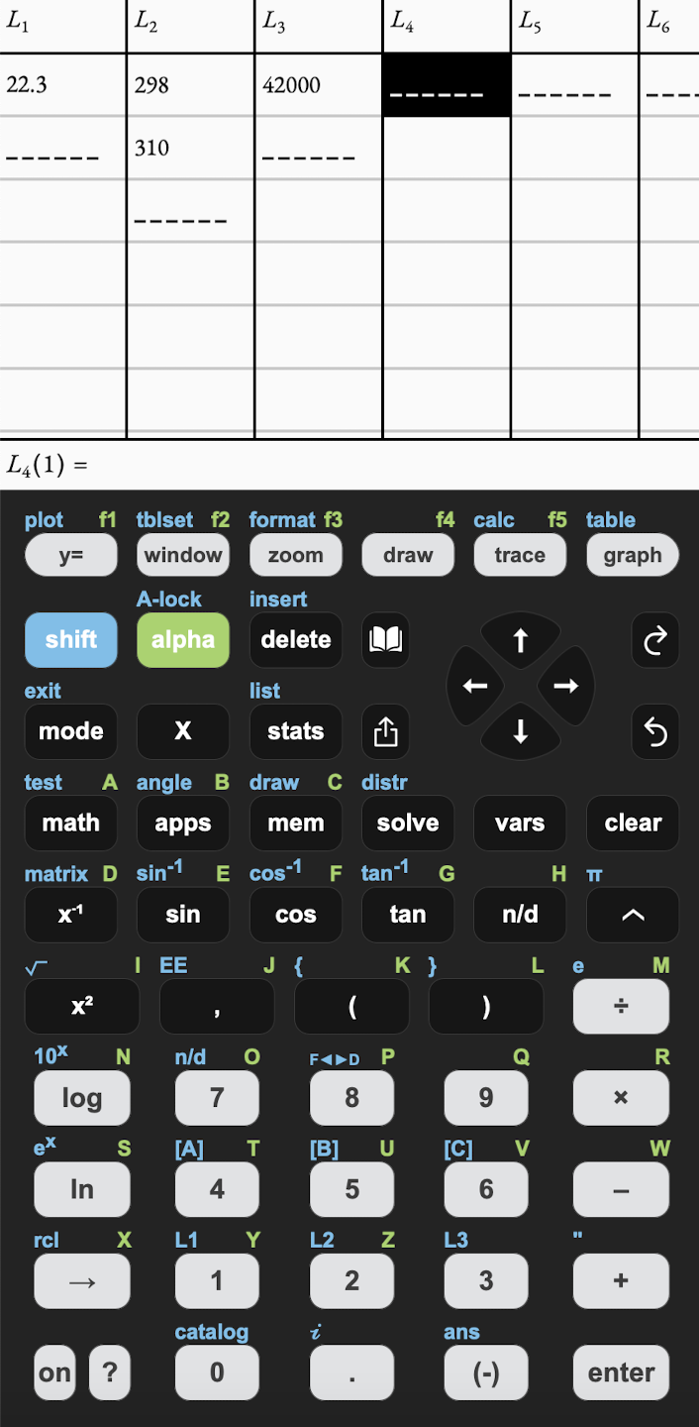

L1 | L2 | L3
P1 | T1 | ΔHvap
P2 | T2

L1 | L2 | L3
22.3 | 298 | 42000
0 | 310
*Note: Make sure to put 0 in the unknown space

Step Four: Select Quit

Step Five: Select Program Option

Step Six: Select Vapor Pressure Program

Step Seven: Select Enter to Run Program

P2= 42.98

Vapor Pressure Program for TI-84 Calculator

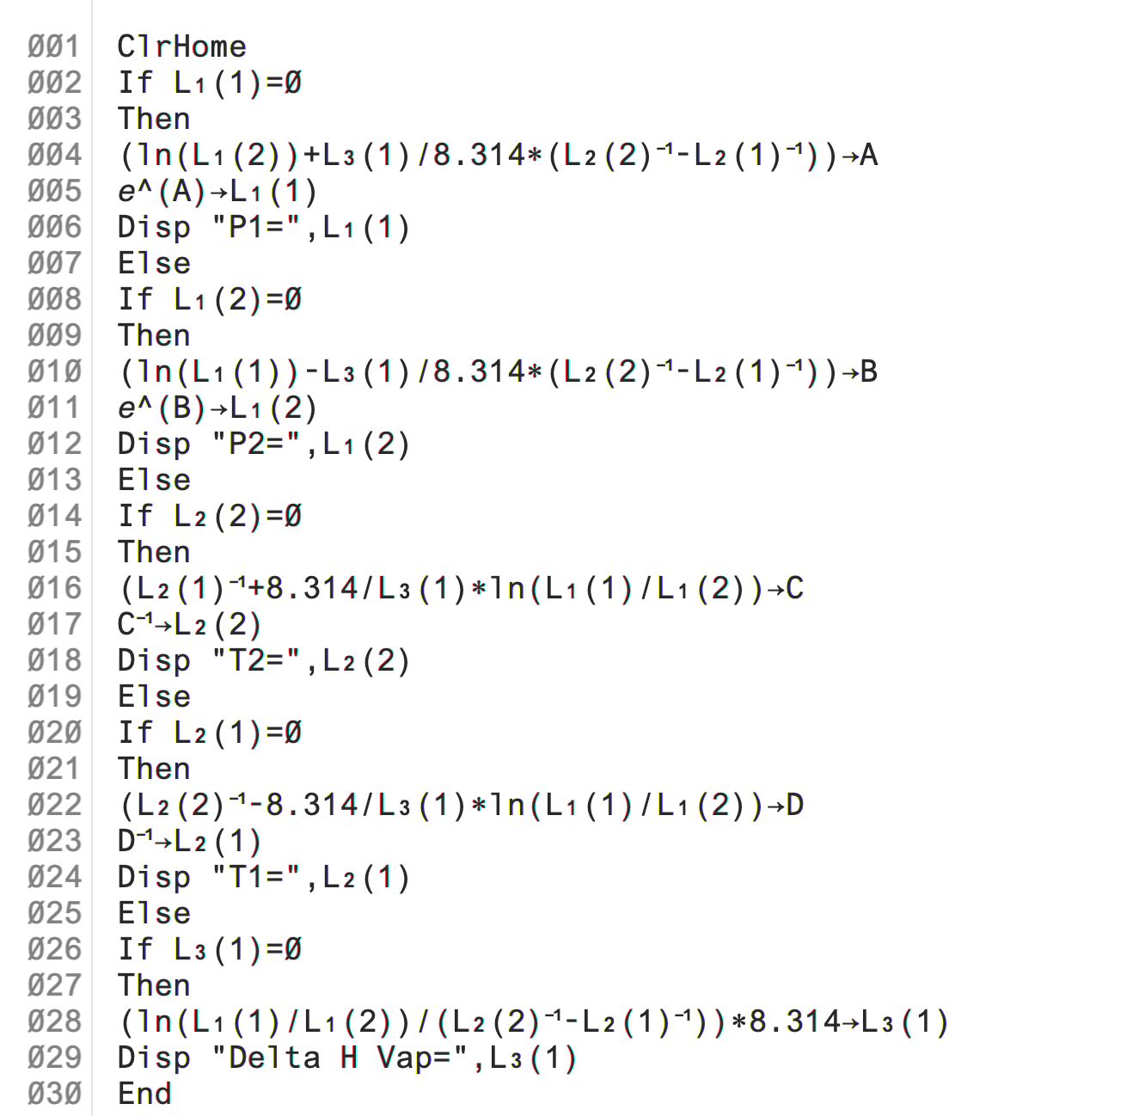

Phase Change
A phase change occurs when matter changes to/from one state to another. The phase change diagram is a visual for how these changes occur at what temperature and pressure. Researchers use the Phase change diagram to be aware of what conditions a pure substance can exist in multiple states of equilibrium.

Phase Change Program

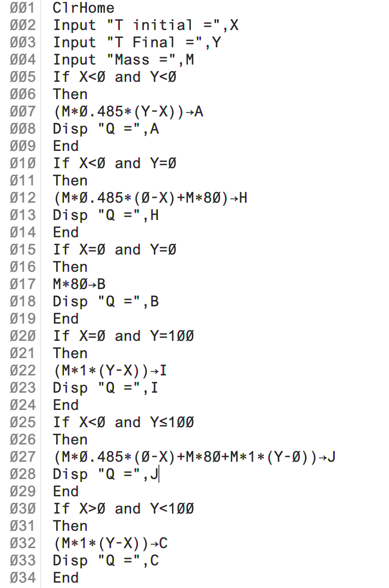
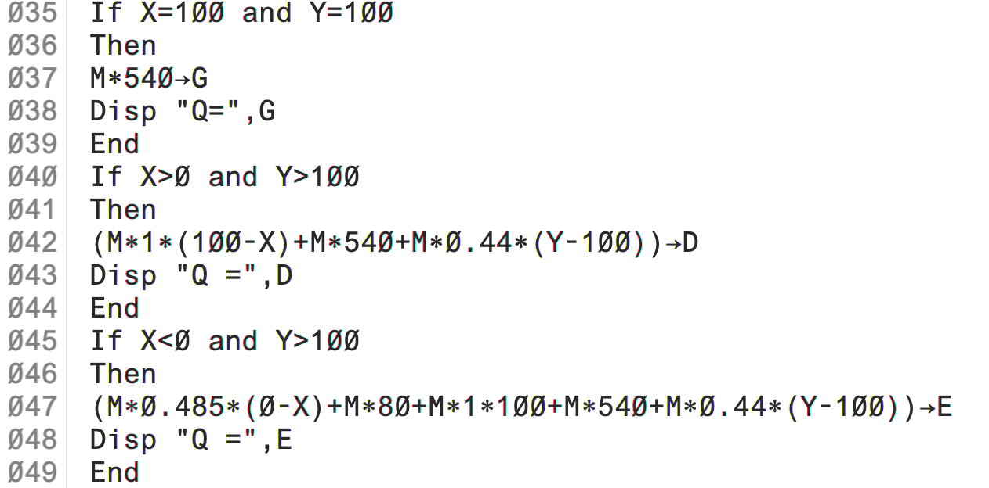

Phase Change Procedure for TI-84 Calculator
Q= MC∆T
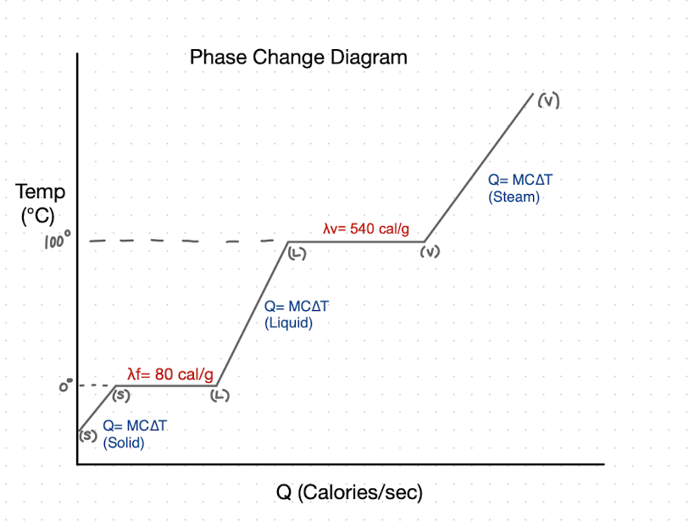

Step One: Select Program

Step Two: Enter Values as Prompted

Example problem:
T initial = -2 °C
T final = 120 °C
Mass = 100 g
Answer Given:
Q= 72,977 cals

Survey
- Did you find these programs useful?
- Did you find the procedure for balancing simple and complex equations clear and easy to understand?
- Did you find the procedure for limiting reactions clear and easy to understand?
- Did you find the procedure for balancing redox equations clear and easy to understand?
- Did you find the procedure for vapor pressure problems clear and easy to understand?
- Did you find the procedure for phase change problems clear and easy to understand?
- Are you likely to use these in the future?
- Are there any improvements that should be made to make these program procedures easier to understand?
References

New very hard problems of balancing chemical reactions (no date). Available at: https://www.people.iup.edu/rbouchat/course_docs/math171/hardchembalance.pdf (Accessed: November 22, 2022).

From chemistry to linear algebra: Balancing a chemical reaction ... (no date). Available at: https://www.researchgate.net/publication/313515058_From_Chemistry_to_Linear_Algebra_Balancing_a_Chemical_Reaction_Equation_Using_Algebraic_Approach (Accessed: November 22, 2022).
TI-Basic Programming Guide for the TI-84 Plus CE Graphing Calculator… (no date). Available at: https://education.ti.com/html/webhelp/EG_TI84PlusCE/EN/index.html (Accessed: November 12, 2022)
TI Codes: TI-84 Plus Technology … (no date). Available at: https://education.ti.com/en/activities/ti-codes/84/10-minutes (Accessed: November 10, 2022)
TI-83+/TI-84 Tutorial: The Basics, Graphing, and Matrices … (no date). Available at: https://www.montgomerycollege.edu/_documents/academics/support/learning-centers/mapel/calculators-for-beginners.pdf (Accessed: November 14, 2022)

